Upgrade Announcement
Version 6.0 for Vista is now available!
---------------------------------------  A preview of what’s new in 6.0:  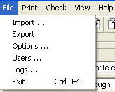 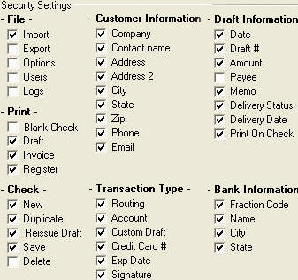  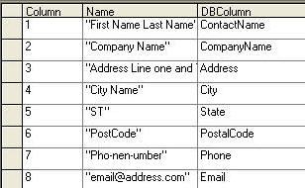 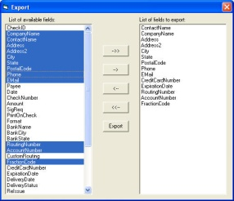  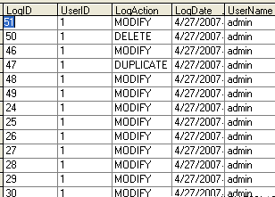 | NEW FEATURES  ___________________________  Single User Version:  • Effortless Double Click Installation from CD ROM  • Password Protected w/1-username and password for security  • Easy to Learn, Easy to Train  • Saves All Customer and Transaction Records  • Allows for Customer Notes / Print Invoices  • Works at any U.S. Bank  • Prints Checks and Check Drafts for immediate deposit  • Accepts Credit Union and Bank Checking Information  • Prints Customer Reports or Individual Data Sheet or Invoice  • WebDebit™ Internet Payment Option Included  • Set up Automatic Monthly Billing / Recurring Payments  • Batch Printing – 3 per page or 1 up printing options  • Automatic Routing Number Validation  • Online RoutingTool provides Funds Verification Phone Numbers  • Text file Import / Export to Excel (.csv) or .txt  • Invoice and Stub: Compatible with #10 Window Envelopes  • Has 2 User Defined Fields – Searchable  • Prints Checks and Drafts up to $999,999.99.  • Mapable Import and Export Functionality: [NEW for 6.0]  Create and import from any file and export in any format.  • Keeps an activity log of all transactions / logins / deleted items  • Binoculars Search Toolbar Button  - Search or Sort by any field from the main screen  ___________________________  Network Edition: All above features plus -  • Works on LAN, in multi user environment [call center]  • Each Terminal Using CheckWriter Shares One Database  • Standard License Covers 3 Terminals [seats] add up to 7 more.  [NEW for 6.0]  • Administrative Login: Full Functionality [customize permissions]  • User Login: [customize permissions for each individual user]  • Standard License Covers 3 [seats] add up to 7 more.  ___________________________  Enterprise Edition: All above features plus -  [NEW for 6.0]  • Standard License Covers 10 Terminals [seats]  add unlimited numbers of additional seats  • Print Drafts with dollar amounts in the Millions +
Please Call With Any Questions: 617-859-8998 or toll free (800) 893-6001
The CheckWriter™ Upgrade is available to existing users of the software only. Free shipping offer is good through date of expiration only. Coupon must be entered by customer at the time of the order. Discounts cannot be applied once an order number has been generated in the system.
Please see http://checkwriter.net for additional terms and conditions and for the software license agreement.

